*Florida International University*

*School of Computing and Information Sciences*

Software Engineering Focus

Feature Document

User Story #215

# Implementing subscription form

**Name:** Nathally Perez

**Team Member(s):** Mariana Sebastian

**Project:** Driverless Car Website 1.0

**Product Owner(s)**: Kianoosh G. Boroojeni

**Mentor(s)**: Mohsen Taheri

**Instructor**: Masoud Sadjadi

**User Story Name: Implementation subscription form**

As a user, I want to be added to the driverlesscar mailing list, so that I will get updated news about the driverlesscar website.

Acceptance Criteria

* A subscription form should be provided
* User information must be saved in the database
* User will be provided a pop up box after entering their information

**Use Case #215**

1. Name:Implementing subscription form
2. Actor: User of the website
3. Preconditions: Have access to internet
4. Description <Flow of events>:
5. Use case starts when user enters <http://localhost:4000> to the browser
6. Scroll down to footer
7. Enter name and email and click submit
8. Get pop up box
9. Post request to db

**Use Case Diagram**

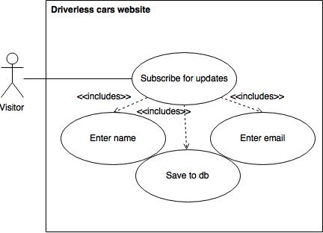

**Sequence Diagram:**

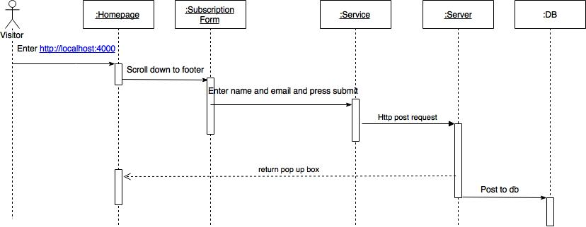

**Class Diagram:**

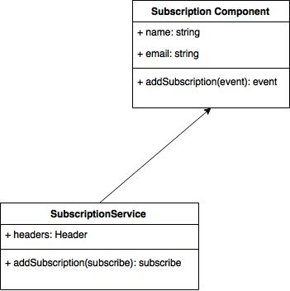

**Unit Test**

**Test case 1(Sunny Day)**

* Test case ID: DCW-215-01
* Description/Summary of Test: Ensure that the subscriber information is being stored to the database properly.
* Pre-condition:

1. The server is running on the localhost port 4000
2. Visitor is in the homepage.
3. Visitor scrolls down to footer
4. Visitor enters:
   1. name
   2. email
5. Visitor clicks subscribe button

* Expected Results: Subscription form is sent correctly
* Actual Result: Subscription form was sent successfully.
* Status (Fail/Pass): PASSED

**Test case 2(Rainy Day)**

* Test case ID: DCW-215-02
* Description/Summary of Test: Visitor leaves a field empty
* Pre-condition:

1. The server is running on the localhost port 4000
2. Visitor is in the homepage.
3. Visitor scrolls down to footer
4. Visitor enters:
   1. name
5. Visitor clicks subscribe button

* Expected Results: Subscription form is not sent correctly since there email was not enter.
* Actual Result: Visitor was not able to subscribe correctly
* Status (Fail/Pass): PASSED

**Integration Test**

The integration test was made using postman and I tested subscribing visitors to the web page and sending the data to the database, and I did not have bugs and they were functioning correctly. The result were positive.

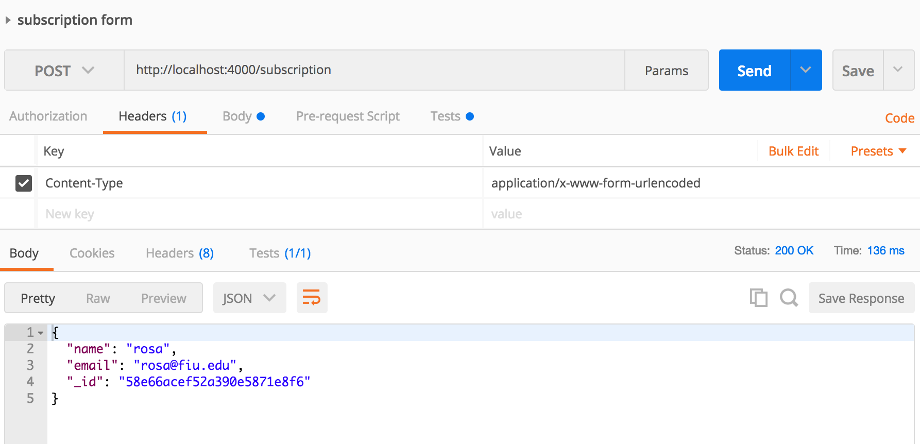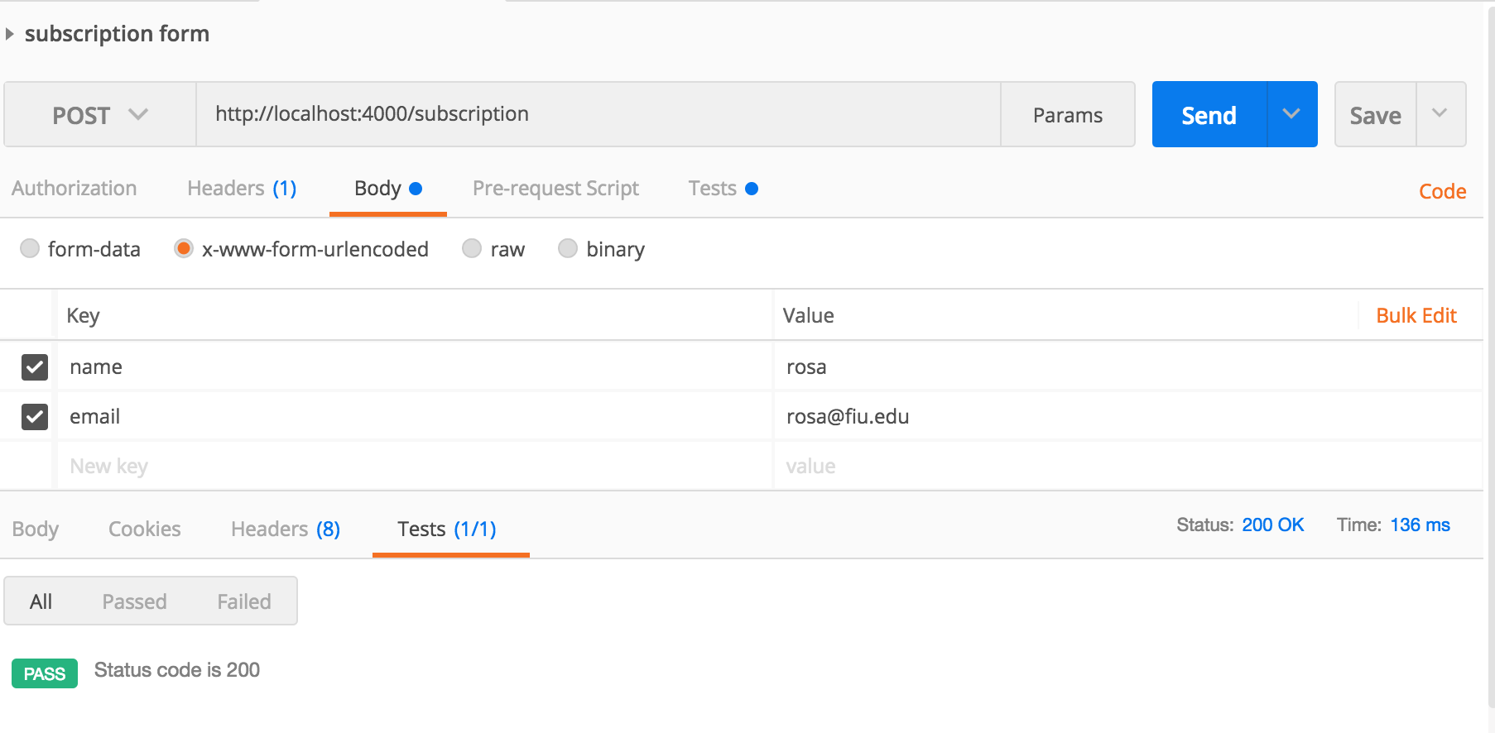

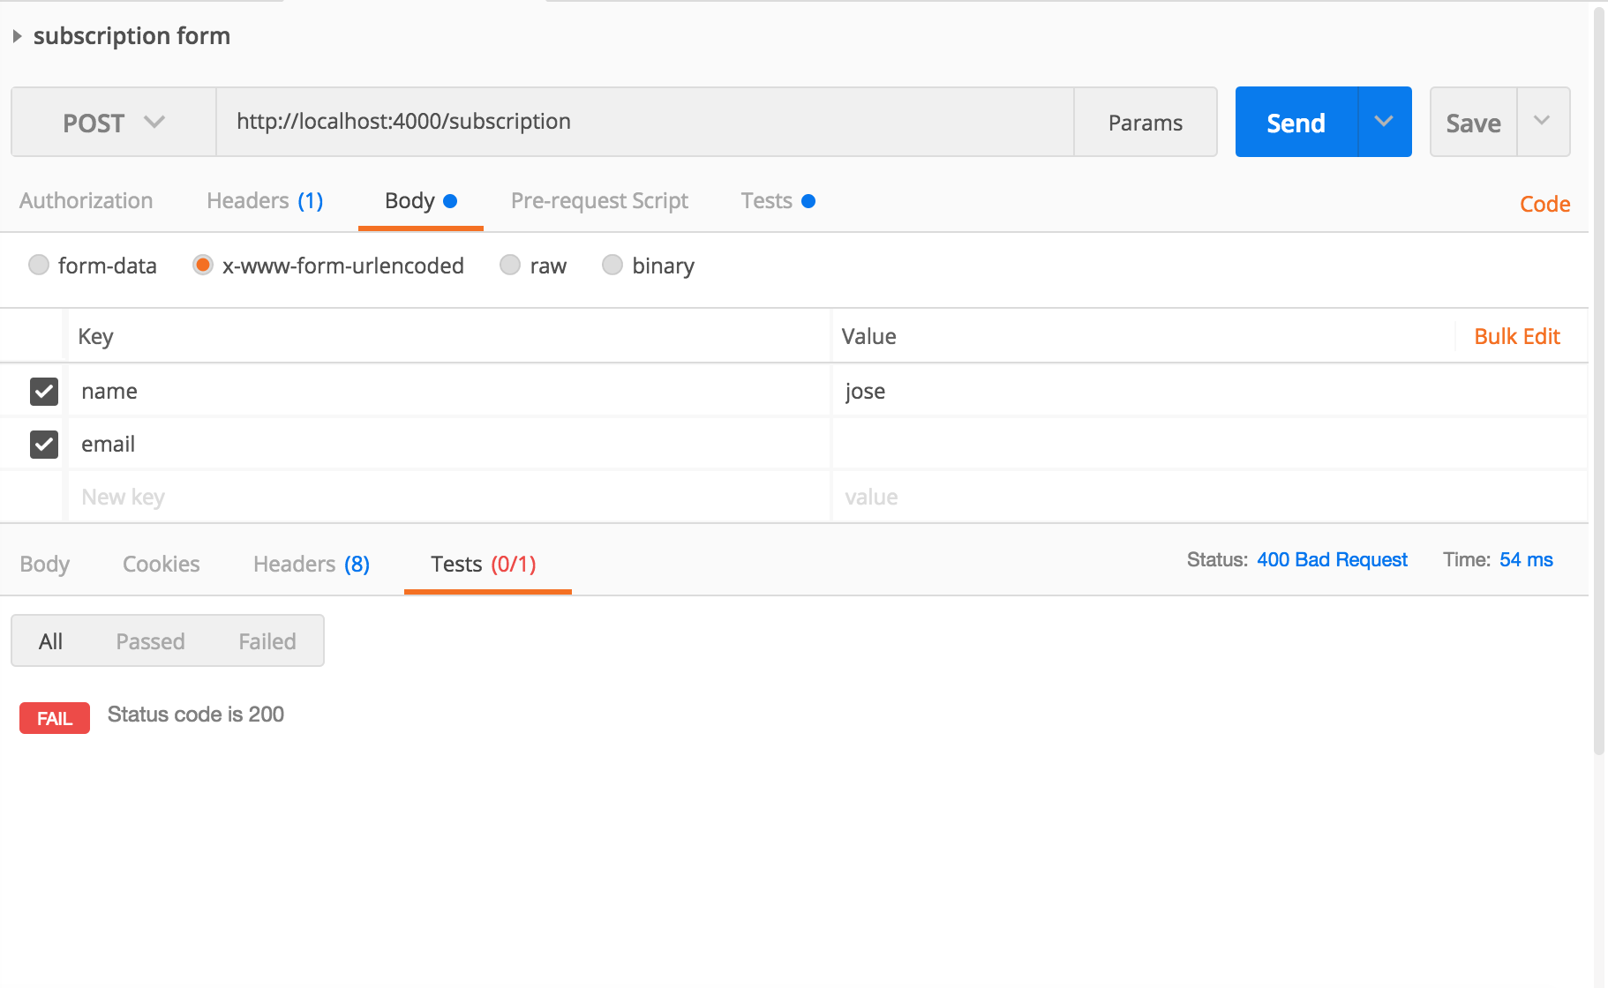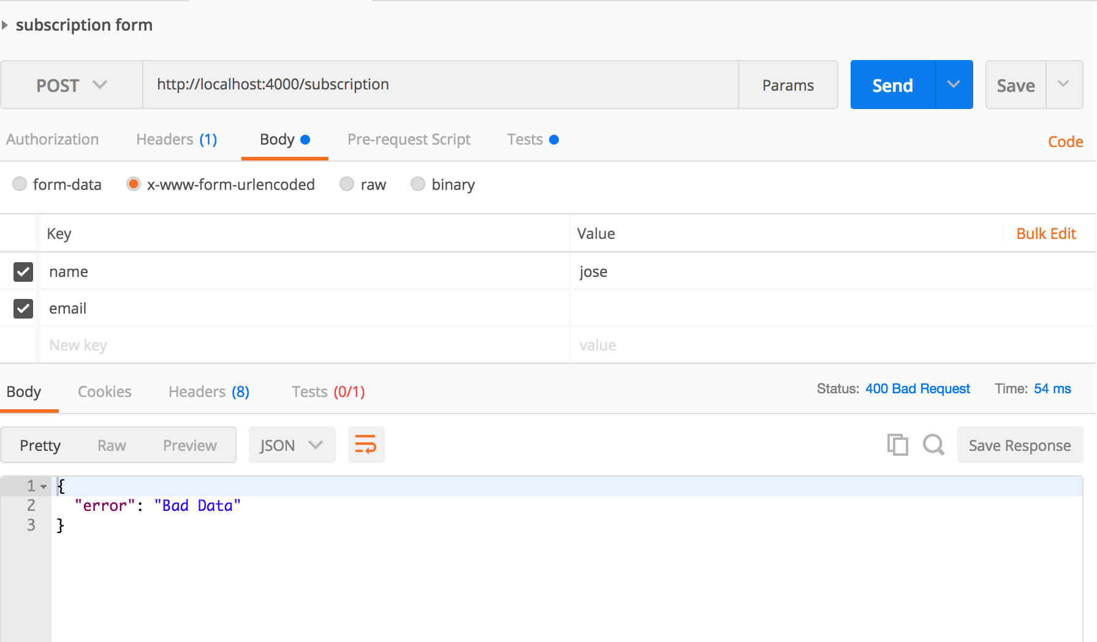

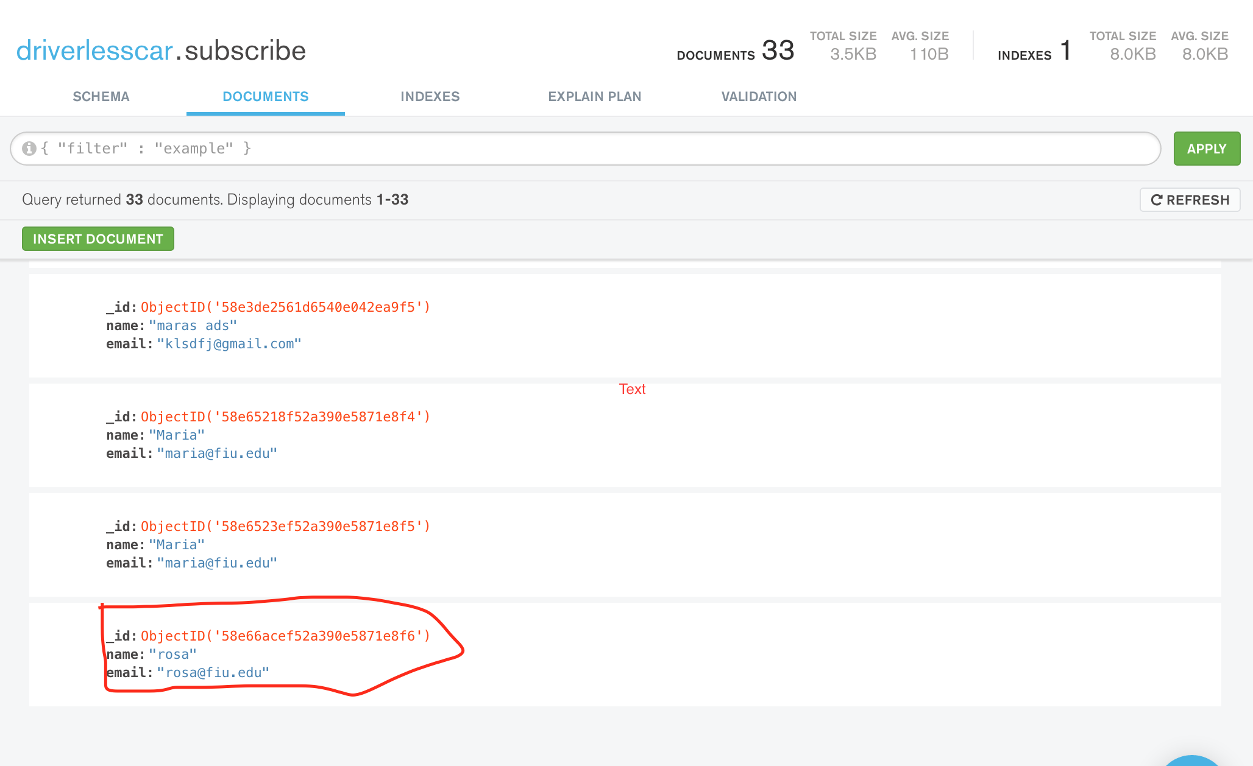

**Visual User Guide** :

